2. Perform 5 data visualization tasks on the student performance dataset given in the link below (create 5 different visualizations). Explain what kind analysis has become easier with each of the visualizations   
Data link: https://app.box.com/s/ji910ez3ycw137rw07xnhielxey7ww41

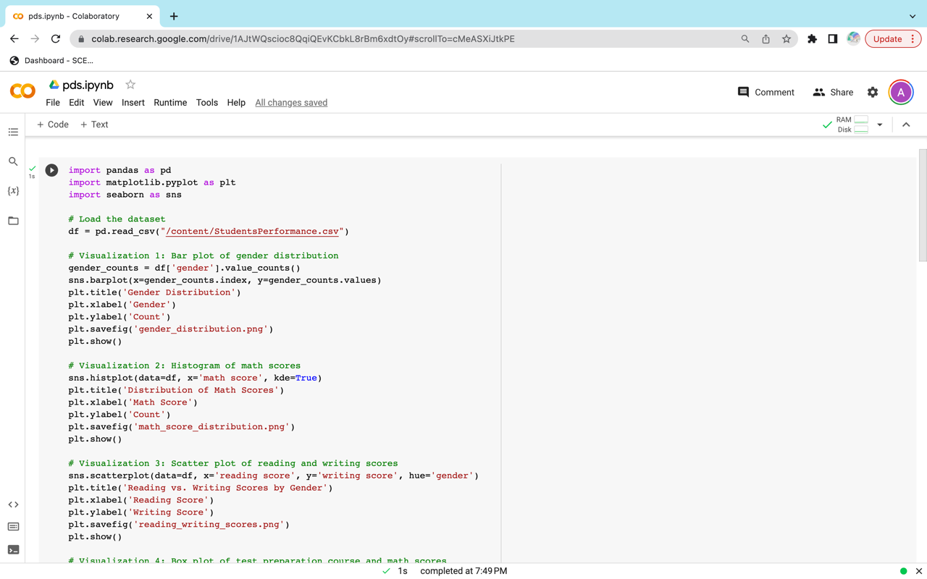

The above line of code begins by loading the dataset by utilizing Pandas. After that, five distinct visuals are crafted with the help of the Matplotlib and Seaborn libraries.

* The first visualization depicts the gender breakdown of the entire dataset as a bar chart. This gives us a better understanding of the proportion of male to female students that are included in the dataset.
* The second chart presents the data in the form of a histogram. This visualization assists us in gaining a better understanding of the distribution of arithmetic scores within the dataset, which in turn can assist us in identifying any potential outliers or skewness within the data.
* The third visualization is a scatter plot that compares the reading and writing scores of each participant's gender. This sheds light on whether or not there is a correlation between reading and writing scores and whether or not this correlation varies according to gender.
* The fourth visualization is a box plot of the math scores broken down by gender and test preparation course. With the use of this visualization, we were able to identify any disparities in mathematical scores that may have been caused by the gender or the test preparation course.
* The correlation matrix is represented here as a heatmap by the fifth visualization. This helps us comprehend the correlation between the many variables in the dataset, which in turn enables us to recognize any patterns or relationships that may exist. For instance, we can observe that there is a significant positive association between the amounts of time spent reading and writing.